Main VK Blog Webpage



VK Blog website

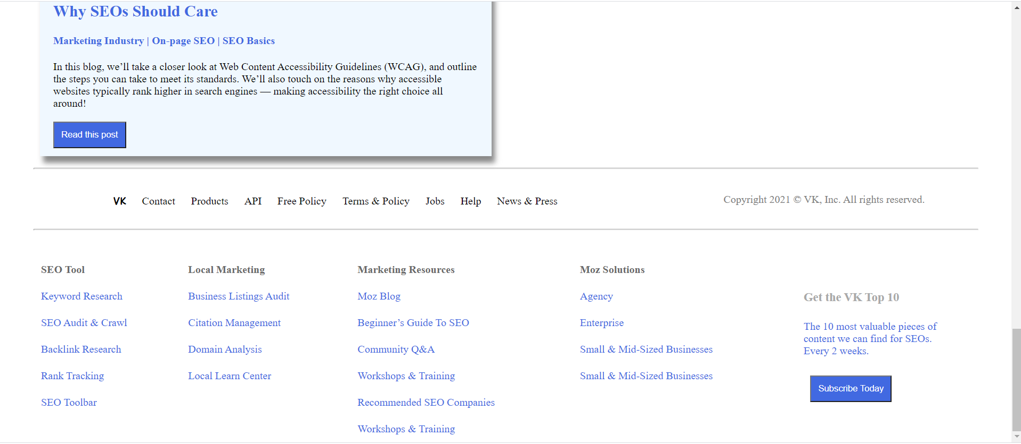

Click on Login inorder to add the blog content. Login with Admin credentials.

Login Page will be displayed on click on “Login” in navigation bar

Login with Admin credentials:

Username - Admin

Password- 12345

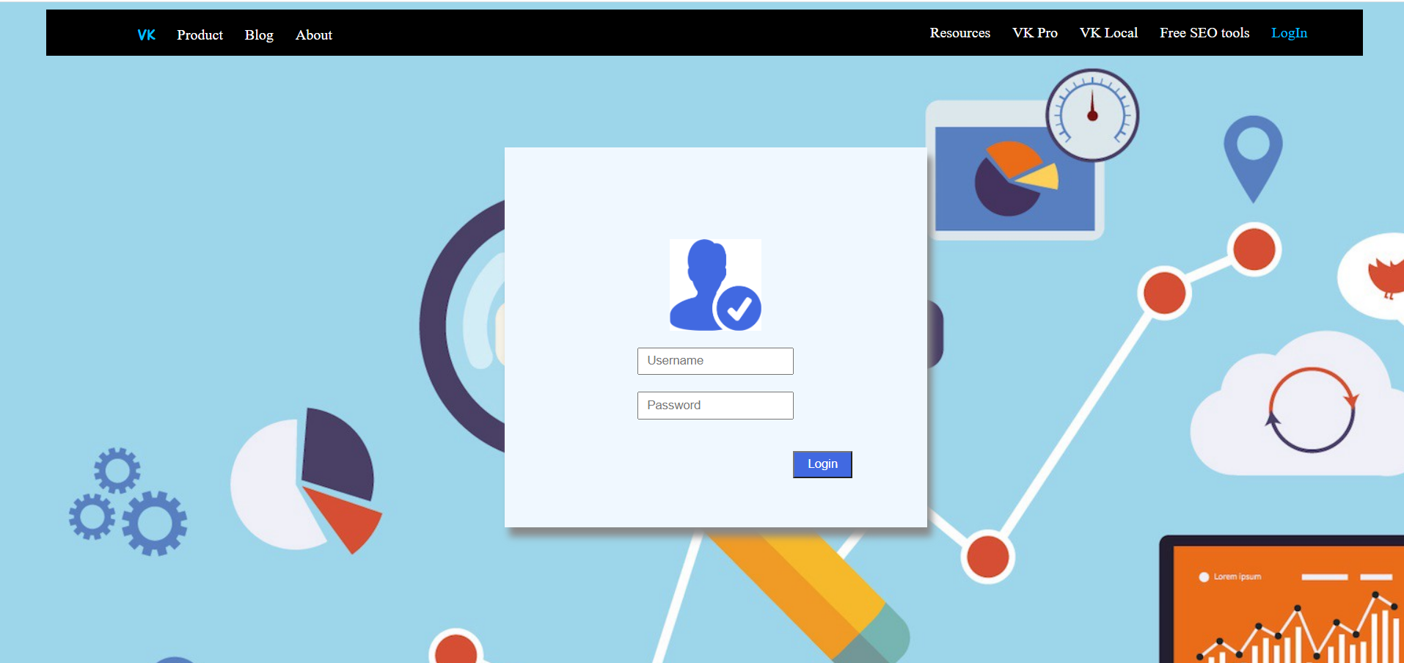

After Login “Add Blog Content” and “Post Blog Content” buttons will be displayed

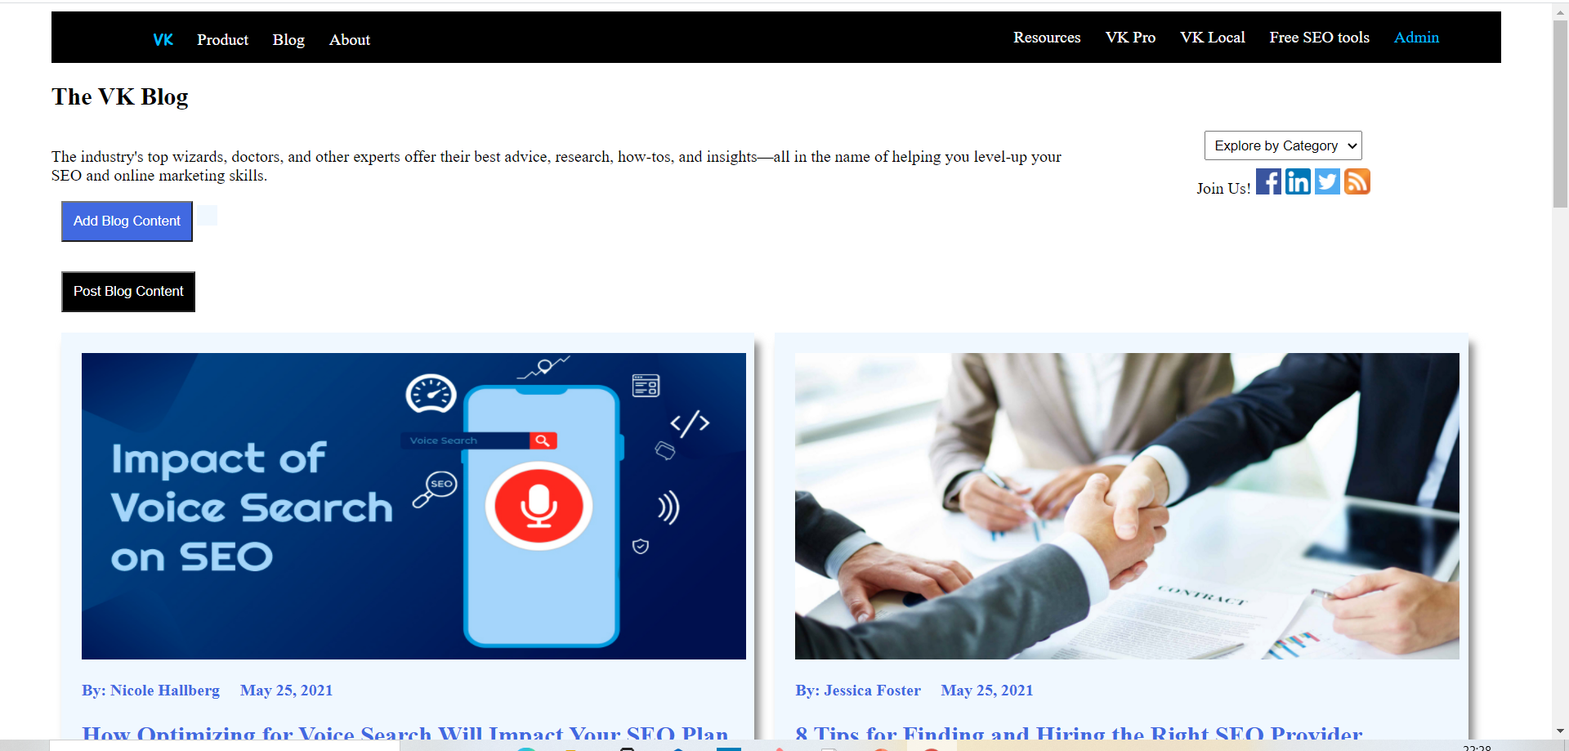

“Add Blog Content” button is used to add all the blog content such as header, brief content and the full content

Add the following content:

Content1:

1. Click on Add Blog Content button

2. Add the following for the Name: [Cooper Hollmaier](https://moz.com/community/users/16919677)

3. Add the following for the Post Header: [SEO and Accessibility: Technical SEO [Series Part 3]](https://moz.com/blog/technical-seo-and-accessibility)

4. Add the following for the Brief Post content:

We hope you’ve enjoyed this series on SEO and accessibility. In the final installment, Cooper shows you how the technical SEO strategies you implement across your site can help make it more perceivable, operable, understandable, and robust.

5. Add the following for the Post content:

We hope you’ve enjoyed this series on SEO and accessibility. In the final installment, Cooper shows you how the technical SEO strategies you implement across your site can help make it more perceivable, operable, understandable, and robust.

6. Click Save content

7. Click on “Post Blog Content”

Content2:

1. Click on Add Blog Content button

2. Add the following for the Name: [Cheryl Draper](https://moz.com/community/users/4164011)

3. Add the following for the Post Header: [The MozCon Virtual 2021 Final Agenda](https://moz.com/blog/mozcon-2021-final-agenda)

4. Add the following for the Brief Post content:

MozCon Virtual 2021 is right around the corner! Read on to see what this year has in store, and don't forget to purchase your ticket!

5. Add the following for the Post content:

MozCon Virtual 2021 is right around the corner! Read on to see what this year has in store, and don't forget to purchase your ticket!

6. Click Save content

7. Click on “Post Blog Content”

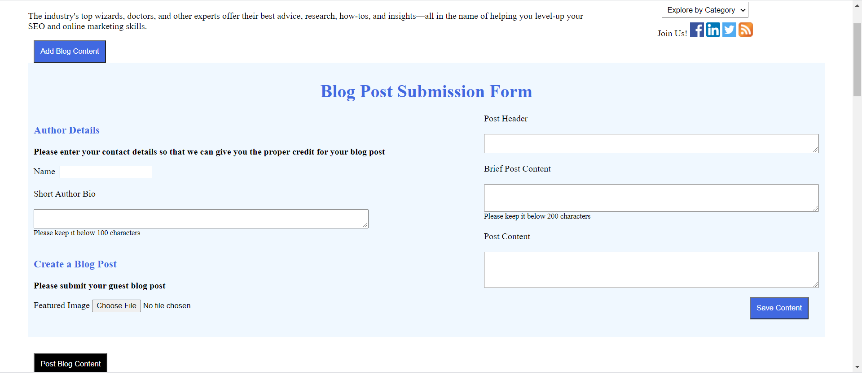

After click on “Save Content” the entered blog content will be save and message ‘Content successfully saved!’ message is been displayed.

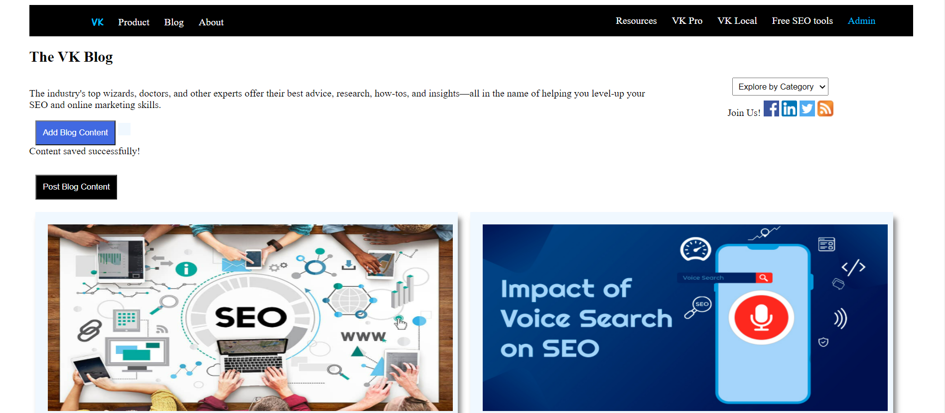

Onclick on “Post Blog Content” button the blog content will be posted on the main blog webpage as displayed below

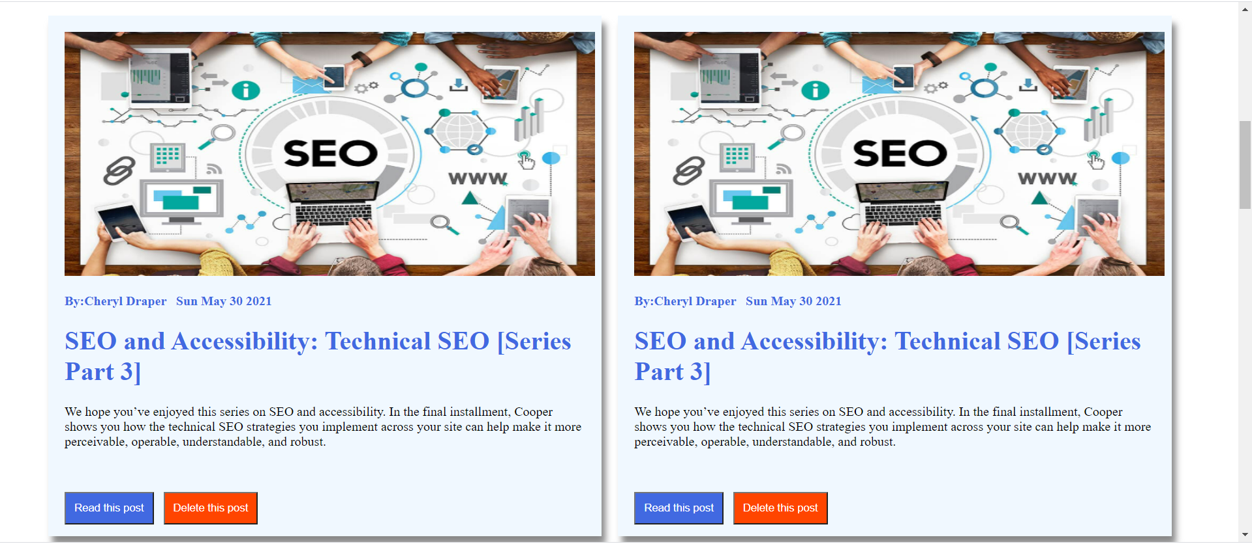

Onclick on “Delete this post” button the posted blog will be deleted as shown in the below screenshot

